**Velagapudi Ramakrishna Siddhartha**

**Engineering College**

**Kanuru, 520001**



**BUSINESS INTELLIGENCE**

**HOME ASSIGNMENT - 1**

**Code : 20IT7403 A**

**Submitted To :**

**Dr . G . Jaya Lakshmi**

**Department Of IT**

**Batch Members :**

**208W1A12A0**

**208W1A12A1**

**Question – 19 :**

Customer’s growing business, recent acquisitions, and evolving data and analytics landscape (including cloud migration) required a change in how its staff leverages data and derives actionable insights. The existing data analytics setup had too many moving parts; the company’s strategy needed an overhaul. Moreover, expectations regarding data and analytics were higher than ever before.

<https://www.infocepts.com/resources/case-studies/accelerated-data-provisioning-improves-time-to-value/>

**Solution :**

The importance of data and analytics in driving business success has never been higher, and companies that fail to adapt risk falling behind their competitors. In this context, it is not surprising that a growing business, recent acquisitions, and an evolving data and analytics landscape have forced a company to re-examine its data strategy.

One of the key drivers for change is likely the sheer volume of data that modern businesses generate. As more and more aspects of our lives move online, companies are collecting more data than ever before on their customers, their operations, and the wider business environment. This presents both an opportunity and a challenge. On the one hand, data can be a powerful tool for gaining insights into business performance, customer behavior, and market trends. On the other hand, processing, analyzing, and interpreting all this data can be a daunting task.

For a growing business, this challenge is compounded by the need to integrate data from multiple sources. In addition to data generated by its core business operations, the company may also have acquired data from other businesses as part of recent acquisitions. These datasets may be in different formats, stored in different systems, or have different levels of quality. Bringing them together in a coherent way is a significant undertaking.

The evolving data and analytics landscape is also a key driver for change. The move towards cloud computing has revolutionized the way data is stored, processed, and analyzed. The scalability, flexibility, and cost-effectiveness of cloud-based solutions make them an attractive option for many businesses. However, migrating to the cloud is not a straightforward process, and requires careful planning and execution.

All of these factors combine to create an environment where the existing data analytics setup may no longer be fit for purpose. As the company has grown and evolved, its data needs have changed, and its data strategy must adapt accordingly. This means re-evaluating the tools, processes, and skills that the company uses to derive insights from its data.

A successful data strategy should start with a clear understanding of the company's business objectives. What are the key drivers of value for the business? What are the most important metrics for measuring performance? What are the biggest challenges facing the company? By answering these questions, the company can begin to develop a set of data-driven goals that align with its broader strategy.

Once the goals have been defined, the company can then begin to look at the tools and technologies that it needs to achieve them. This might involve upgrading or replacing existing systems, investing in new analytics platforms, or migrating to the cloud. Whatever the solution, it should be tailored to the specific needs of the business, and take into account factors such as data volume, complexity, and security.

However, technology alone is not enough. The success of a data strategy also depends on having the right people with the right skills. This means hiring or upskilling staff who can work with the latest data tools and technologies, and who have a deep understanding of the business and its data needs. It also means creating a culture that values data-driven decision-making, and that encourages experimentation, collaboration, and continuous learning.

Finally, a successful data strategy requires a focus on governance and compliance. As the company collects and processes more data, it must ensure that it is doing so in a responsible and ethical way. This means having clear policies and procedures in place for data privacy, security, and management, and ensuring that all staff are trained in these areas.

In conclusion, the growing importance of data and analytics, coupled with a changing business environment, has forced a company to re-evaluate its data strategy. By starting with a clear understanding of business objectives, and then developing a tailored solution that takes into account factors such as data volume, complexity, and security, the company can create a data-driven culture that drives business success. However, this requires not only investing in the right technology, but also in the right people and processes, and a focus on governance and compliance. The result is a data strategy that is fit for purpose, that enables the company to derive actionable insights from its data, and that supports its broader business objectives.

One of the key benefits of a data-driven approach is the ability to make more informed and effective decisions. By analyzing data from different sources, companies can gain a more complete view of their business, their customers, and the wider market. This, in turn, allows them to identify new opportunities, mitigate risks, and make better strategic decisions.

For example, a retail company might use data analytics to optimize its pricing strategy. By analyzing sales data, customer behavior, and market trends, the company can identify the most effective price points for its products, and adjust prices in real-time to maximize revenue. Similarly, a logistics company might use data analytics to optimize its delivery routes, reducing costs and improving efficiency.

Another key benefit of a data-driven approach is the ability to personalize the customer experience. By collecting and analyzing data on customer behavior and preferences, companies can tailor their products and services to individual customers, improving customer satisfaction and loyalty. This can be particularly valuable in industries such as e-commerce and retail, where the customer experience is a key competitive differentiator.

Finally, a data-driven approach can also help companies to stay ahead of the curve in a rapidly evolving business environment. By analyzing market trends and emerging technologies, companies can identify new opportunities and threats, and adapt their strategy accordingly. This can be particularly valuable in industries such as technology and finance, where disruption is the norm.

In conclusion, the growing importance of data and analytics is forcing companies to re-evaluate their data strategy. By developing a tailored solution that takes into account business objectives, data volume, complexity, and security, and by investing in the right people and processes, companies can create a data-driven culture that supports business success. The benefits of such an approach are clear, including more informed decision-making, personalized customer experiences, and a better ability to adapt to a rapidly changing business environment.

**Velagapudi Ramakrishna Siddhartha**

**Engineering College**

**Kanuru, 520001**



**BUSINESS INTELLIGENCE**

**HOME ASSIGNMENT - 2**

**Code : 20IT7403 A**

**Submitted To :**

**Dr . G . Jaya Lakshmi**

**Department Of IT**

**Batch Members :**

**208W1A12A0**

**208W1A12A1**

**Question :**

Create a visually engaging and interactive output for their financial customers. To do this, the company sought out an analytics partner that could help it quickly build a user interface that displayed the unified data in easy to understand, drillable dashboards.

**Solution :**

Firstly, the company should identify the key financial metrics that their customers are interested in, and then create visualizations that represent these metrics in a clear and concise manner. These could include charts, graphs, and tables that allow customers to quickly understand how their finances are performing.

To make the interface more interactive, the company could also include drill-down functionality, which would allow customers to click on specific metrics and access more detailed information. This could be achieved through pop-up windows or expanding sections within the dashboard.

Additionally, the use of color coding and visual cues such as arrows or icons could help customers quickly identify trends and areas of concern. For example, green could be used to indicate positive trends, while red could signify negative trends.

**Banking Dashboard**

**DataSet :**

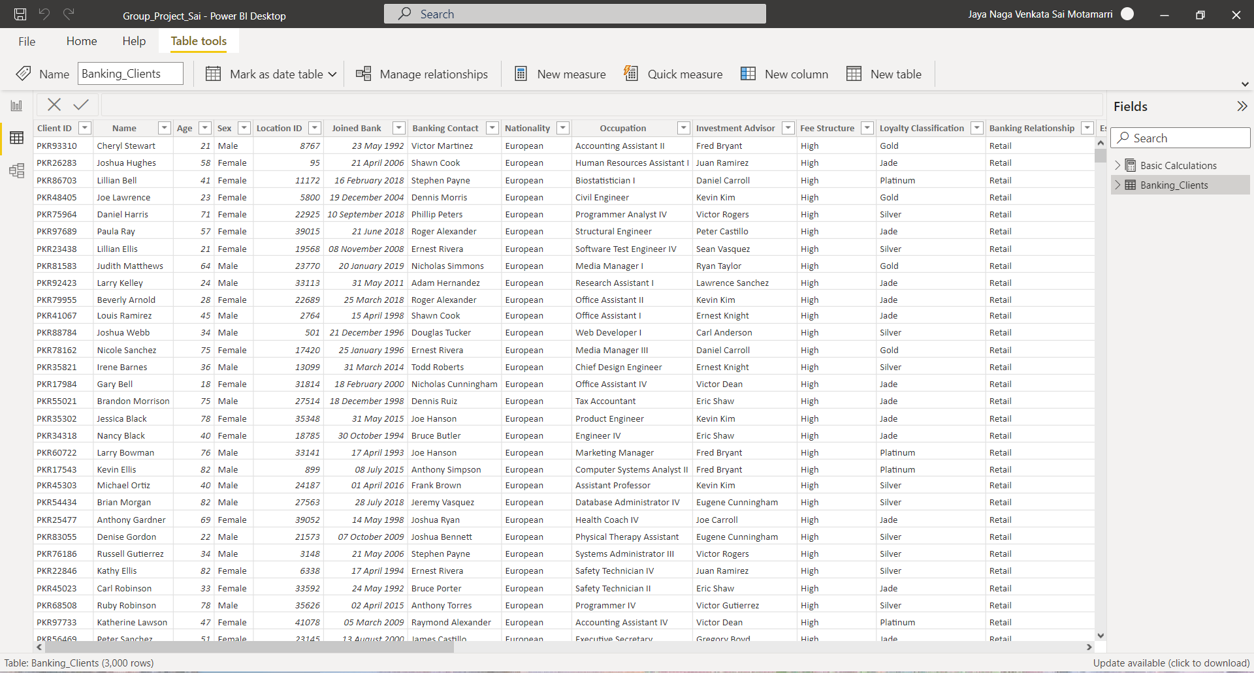

**Data Model :**

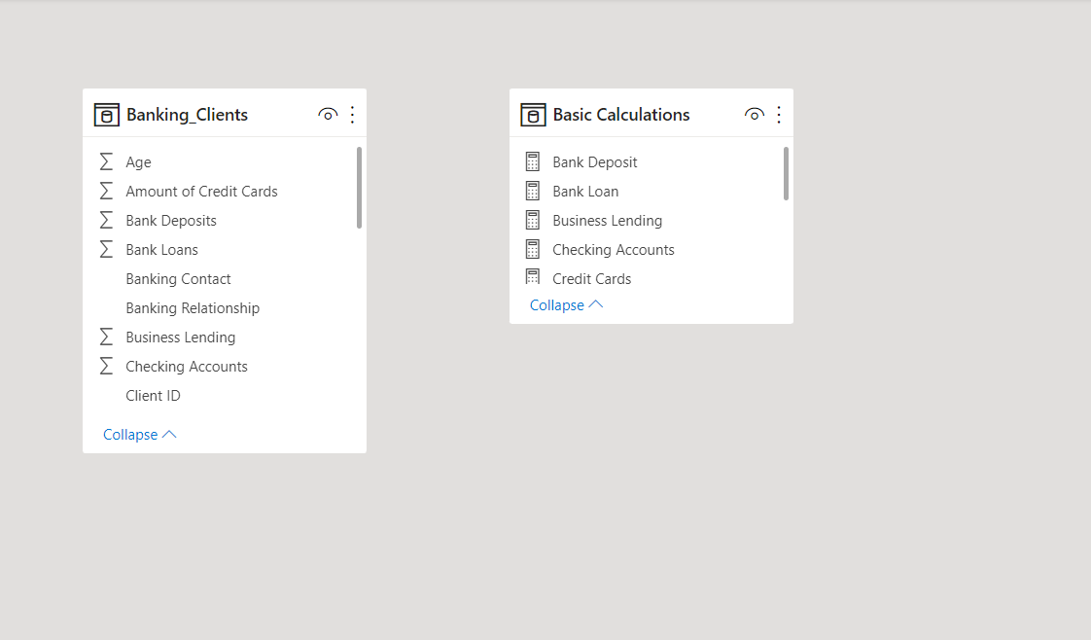

**Dashboard :**

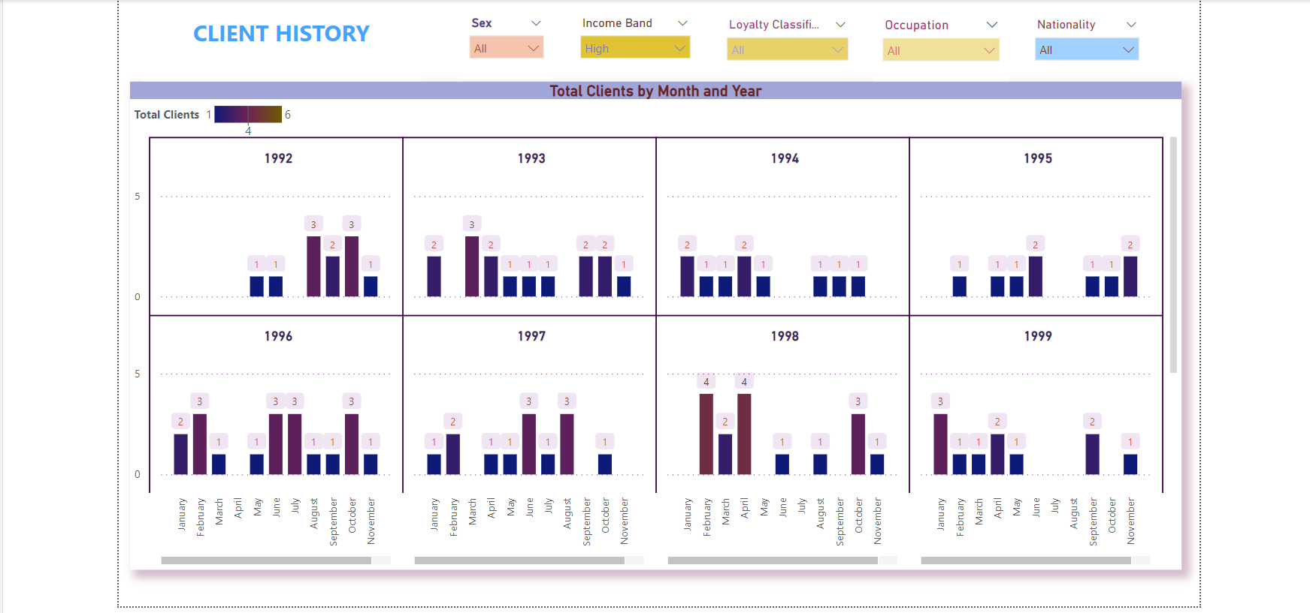

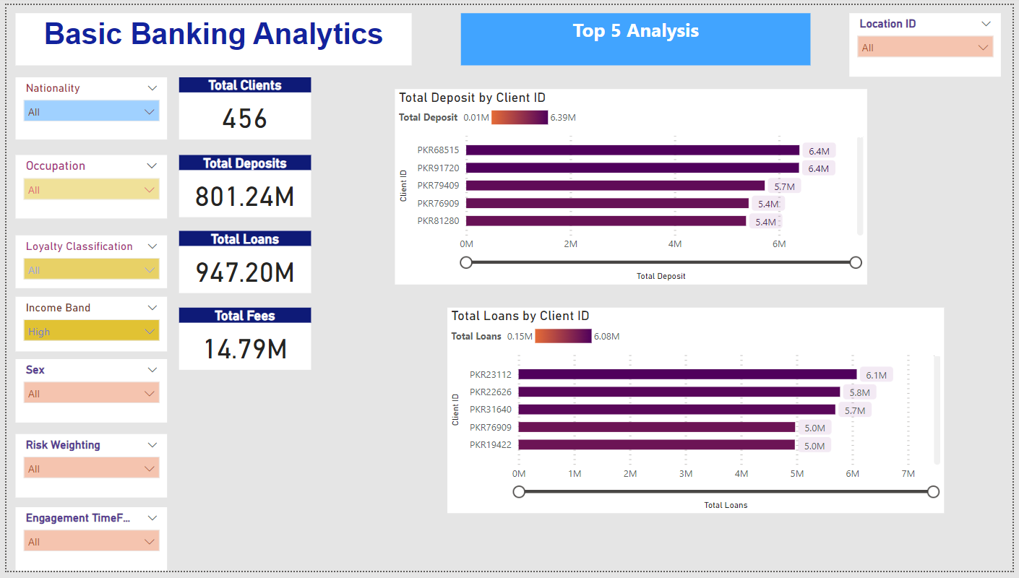

**Velagapudi Ramakrishna Siddhartha**

**Engineering College**

**Kanuru, 520001**



**BUSINESS INTELLIGENCE**

**HOME ASSIGNMENT - 3**

**Code : 20IT7403 A**

**Submitted To :**

**Dr . G . Jaya Lakshmi**

**Department Of IT**

**Batch Members :**

**208W1A12A0**

**208W1A12A1**

**208W1A1A2**

**Question – 14**

Identify how profitability using BI and data analytics for the wholesale and distribution business

<https://www.kaggle.com/datasets/binovi/wholesale-customers-data-set>

**Solution :**

Business Intelligence (BI) and data analytics can help improve profitability in the wholesale and distribution business by providing insights into customer behavior, sales trends, inventory management, and supply chain optimization.

By analyzing the Wholesale Customers dataset available on Kaggle, a wholesale distributor can gain valuable insights into their business operations. The dataset contains information on the annual spending of customers on various product categories like Fresh, Milk, Grocery, Frozen, Detergents_Paper, and Delicatessen. The following are some ways BI and data analytics can improve profitability in this business:

1. Understanding customer behavior: By analyzing the dataset, a distributor can identify the product categories that are most in-demand and tailor their inventory and marketing strategies accordingly. They can also identify customer segments with the highest lifetime value and prioritize their sales efforts.
2. Optimizing inventory management: Using data analytics, a distributor can identify which products have the highest inventory turnover and ensure they are always in stock. They can also identify slow-moving products and take steps to reduce inventory carrying costs.
3. Improving supply chain efficiency: By analyzing data on lead times, delivery times, and supplier performance, a distributor can optimize their supply chain to reduce costs and improve delivery times.
4. Identifying sales trends: By tracking sales data over time, a distributor can identify trends in customer behavior and adjust their pricing and marketing strategies accordingly.
5. Streamlining operations: By using BI tools to track key performance indicators (KPIs) like order fulfillment rates, delivery times, and inventory accuracy, a distributor can identify areas for improvement and optimize their operations.

**Customers Dashboard**

**DataSet :**

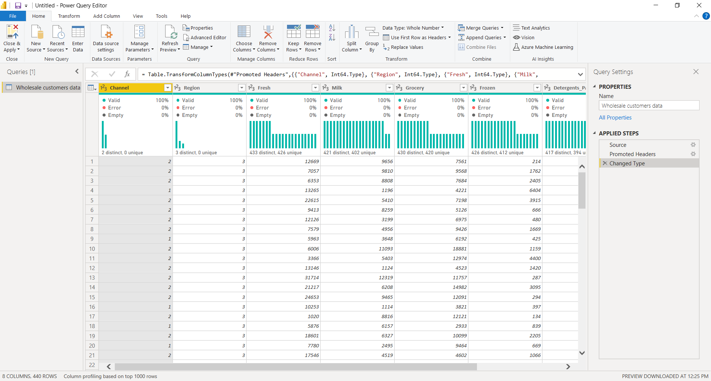

**Dashboard :**

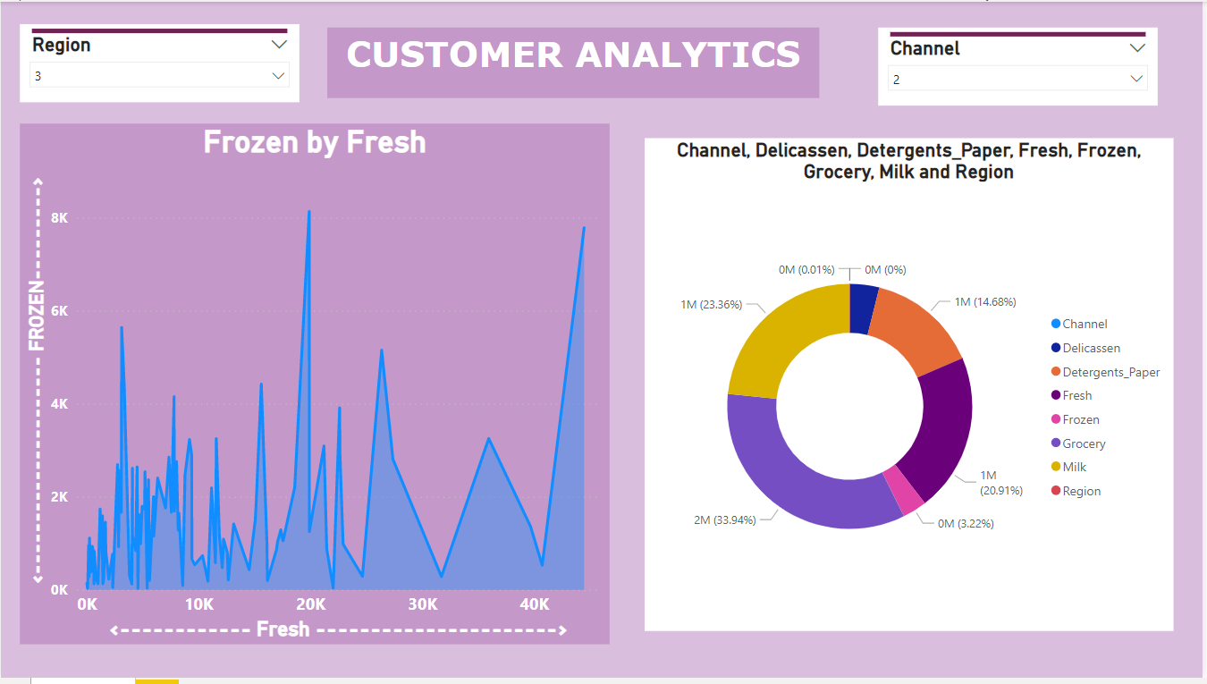

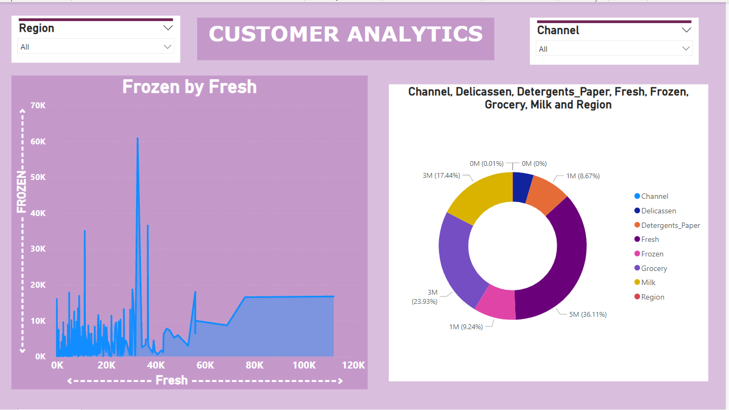

**Velagapudi Ramakrishna Siddhartha**

**Engineering College**

**Kanuru, 520001**



**BUSINESS INTELLIGENCE**

**HOME ASSIGNMENT - 4**

**Code : 20IT7403 A**

**Submitted To :**

**Dr . G . Jaya Lakshmi**

**Department Of IT**

**Batch Members :**

**208W1A12A0**

**208W1A12A1**

**208W1A12A2**

**208W1A12A3**

**Question – 10**

Create a dashboard to interactive tactical dashboard for a human resources department demonstrates a fantastic use of a wide variety of demographics data that is both up to the minute and able to be manipulated to display data from various periods.

**Solution :**

1. Overview: The dashboard should provide an overview of the key HR metrics. This could include things like headcount, turnover rate, employee engagement scores, and time to hire. The overview should be presented in an easily digestible format, such as graphs or charts.
2. Employee demographics: The dashboard should display employee demographic information such as age, gender, ethnicity, and job level. This data can help identify trends and areas for improvement in diversity and inclusion efforts.
3. Recruitment metrics: The dashboard should provide data on recruitment metrics such as the number of job applicants, the number of open positions, and the time to fill open positions. This data can help identify bottlenecks in the recruitment process and areas for improvement.
4. Performance metrics: The dashboard should provide data on performance metrics such as employee performance ratings, training completion rates, and employee satisfaction scores. This data can help identify high-performing employees and areas for improvement in employee development.
5. Compliance metrics: The dashboard should provide data on compliance metrics such as the number of HR-related incidents, the number of investigations, and the number of policy violations. This data can help identify areas for improvement in HR policies and procedures.
6. Customizable data filters: The dashboard should allow users to filter data by various demographics such as age, gender, ethnicity, and job level. This can help identify trends and areas for improvement in specific areas of the workforce.
7. Real-time updates: The dashboard should provide up-to-the-minute data and be capable of displaying data from various periods. This can help HR professionals identify trends and respond to issues in a timely manner.

**HR DASHBOARD**

**HR Glance View :**

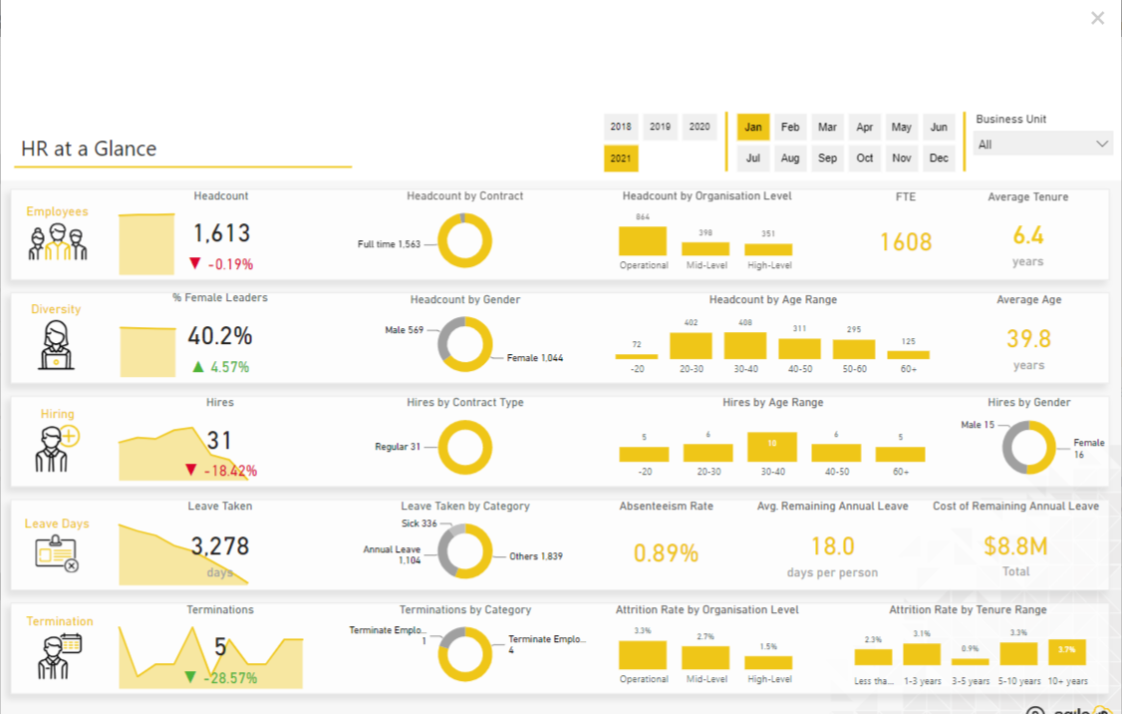

**DemoGraphic Analysis View :**

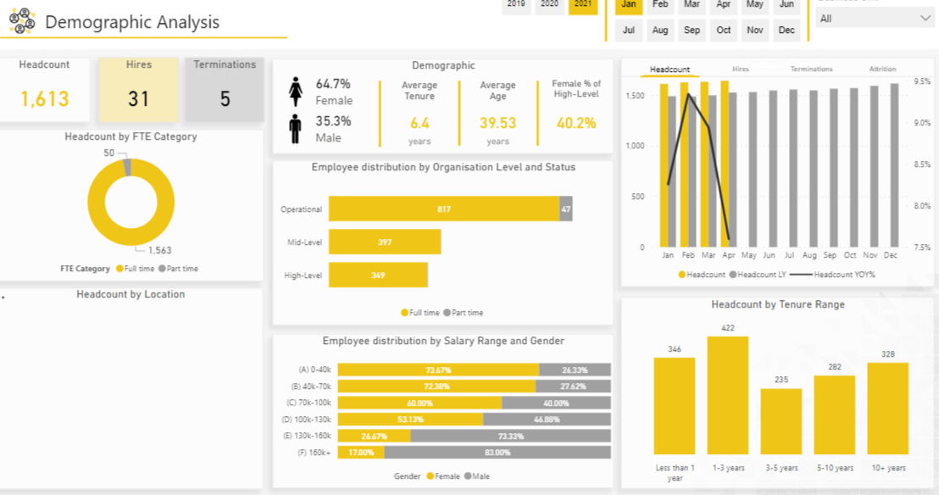

**Diversity in Company :**

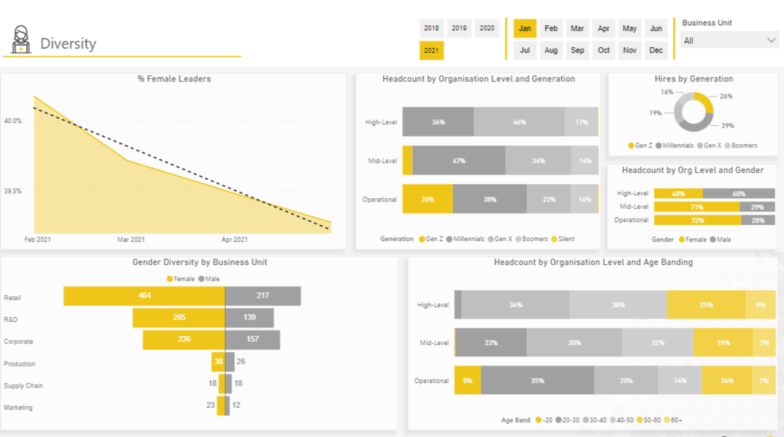

**Employee Profile :**

